Send on Wednesday, May 31st, which is the official last day of the launch – we want to have a big final push on this date)

Subject:
Last chance EVER to “Just Say Yes” for <first>?

Hi <first>,

This is the last time I’ll be able to e-mail you about this:

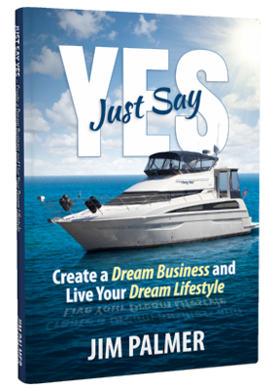

http://www.JustSayYesBook.com/

For the past few days, I’ve been making you aware of the opportunity to claim your free copy of Jim Palmer’s brand-new book.

If you, like me, take seriously the promise of having a dream business that supports your lifestyle and fulfills your dreams, you can rest assured, I’ve read Jim’s book and 100% approve it for you.

You can definitely put this one in the “WIN” column.

But I’d hurry, because I think Jim said this is the last day.

Get it now, claim the same thing those who wait until tomorrow will pay full price to get it (and miss out on the bonuses you can only get at Jim’s book website):

http://www.JustSayYesBook.com/

<INSERT YOUR SIGNATURE>

P.S. One more “pro tip” for you.

If you’ve been held back (or holding yourself back) through all of the “What If” questions, no matter how grounded in practical reality they may be (we realize that taking a giant leap can feel easier said than done)…

…Jim and I give you radical permission to embrace the lessons of Chapter 4 and the process Jim and his wife Stephanie followed as they sold their house and moved onto their dream boat to explore the open waters and sail the coastline full-time.

Last time, here’s that link:
http://www.JustSayYesBook.com/

