Send a few days after Monday, May 15th, it is designed as a resend/follow-up of the e-mail from Launch Day)

Subject:
[RESEND] “Just Say Yes” to this now

Hey <first>,

Just wanted to make sure you got this :)

For the next few days, Jim Palmer is giving away free copies of his brand-new book.

(Cut to the chase? Here’s the link ==> http://www.JustSayYesBook.com/)

Also, just in case you didn’t see it, here’s the e-mail I sent you recently:

=============================================

Subject: <first>, Your FREE Copy Is Ready - (Just Say Yes!)

Hello <first>,

I have some exciting news to share with you!

My friend Jim Palmer, known to many as The Newsletter Guru and Dream Business Coach, has just finished his seventh book.

I had the great pleasure of reviewing an advanced copy – and let me tell you, it totally rocks!!

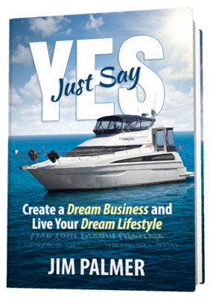

Just Say Yes! Create a Dream Business and Live Your Dream Lifestyle is by far Jim’s best book (IMHO) – the first of its kind specifically designed to empower you and propel you to claim the results in business and life you’ve always wanted.

Two brief passages from Jim’s book sums it up better than I ever could:

“Dreams choose you rather than the other way around. What dream has chosen you? Are you brave enough to pursue it?”

and

“There are only two outcomes when you take the leap, and both result in success – but you gotta jump!”

And that’s why this book is so important – because the notions we’ve been taught up until now about success, failure, and pursuing our dreams, are… in a word… wrong.

Throughout the pages of Just Say Yes! Jim will show you a new path to success, using the lessons of his own journey – from stocking shelves at Target, to running several 6-figure businesses simultaneously, to claiming his dream of living on a boat – as a blueprint that gives you inspiration.

The really cool news is:

Jim Is Giving Away 500 Copies Of This Book For Free – Yes FREE!

You’ll just need to cover the S&H, which is a mere $6.95! In addition, you will also receive a digital copy immediately upon reserving your free book (no waiting), plus some bonuses that will only be available via Jim’s book website.

Claim your free “advance” book copy now!

What makes this book so powerful is that Jim covers so many ‘not usually talked about’ topics that hold many entrepreneurs back – even when they believe they are moving forward.

Listen: I thought I knew Jim already. I was under the impression that I knew his story, having followed his internet TV show, podcast, and blog for so long.

But Jim has dug deeper than I’ve ever seen before.

After reading this book, wow, just wow…

…He left NO stone unturned.

To give you an idea, here are the topics you’ll discover in this powerful book:

* My Journey – Your Blueprint

* Two “F” Words: Fear and Forgiveness

* Success Leaves Tracks

* What If…?

* Everybody Dies

* Seesaws, Leapfrog, and Being Childlike

* Where Are You?

* Just Say Yes to Your Business

* Test Me In this

* Bigger, Bolder, Faster: What’s It All Mean?

As I said, this is one powerful book.

Or, as someone else who reviewed an early copy said:

If someone can even take a nugget of info from this book, like minimizing the head trash and 'what if' game - it's worth the read. Saying YES to the book and business and life can truly bring your dream into fruition. I know, because I've done it!

Claim your free “advance” book copy now!

I hope you take immediate action and get your free copy today at http://www.JustSayYesBook.com/.

<INSERT YOUR SIGNATURE>

P.S. Remember, Jim is giving away 500 Free copies of Just Say Yes! Create a Dream Business and Live Your Dream Lifestyle (just pay $6.95 S&H).

Do not delay as once the 500 Free copies are gone, it will cost you $20 more – and you’ll miss out on the bonuses you can only get by claiming your copy now at Jim’s book website.

One more time, here’s the link:

http://www.JustSayYesBook.com/

