Send ASAP as we’re looking to a) build a huge Thunderclap for the moment of launch, and b) create more prospect and customer engagement overall.

Subject: Are you ready to “Just Say Yes” to the success you want?

Hello <first>,

Did you know that some of the biggest obstacles holding you back may not be obstacles at all – but rather, something else?

Are you skeptical when people say things like “Screw it, let’s do it”, “Say yes, then figure out how”, or “Just jump, and spread your wings in the air?” (Understandable, because up until this moment, no one has properly shown you HOW to succeed this way. On May 15th, that changes, as you’re about to see.)

Do you notice how often entrepreneurs “microwave” their success, rather than take a smart, sustainable approach to achieving the business and life you desire and deserve? (Again, this is because of some gaps in entrepreneurial training, that are about to be resolved for you.)

How would you like an internationally acclaimed business mentor to help you, on a live call, get answers and solutions to the obstacles in your way (which again, may be nonexistent, which you’ll understand once a third party shows you through a new set of eyes)?

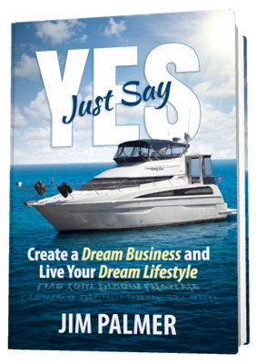

My friend Jim Palmer, known to many as The Newsletter Guru and Dream Business Coach, has just finished his seventh book – and it comes out on Monday, May 15th.

I’m honored to be part of the official launch team helping to spread the “Just Say Yes” message – and I’d love for you to join me.

How does it work?

Simple:

1) Take 90 seconds to join the Thunderclap that goes out on Monday the 15th, when the book hits the virtual shelves. Here’s the link: http://www.JustSayYesBook.com/thunderclap/

This page contains more information about the book, the message, and what inspired Jim to create this new resource for entrepreneurs like you.

2) As soon as Jim sees you’ve Thunderclapped, Jim will send you a personal invitation to an EXCLUSIVE group call where he will expound on the “Just Say Yes!” principles – and give you some live, personalized mentoring and guidance too.

3) The call takes place Tuesday, May 23rd at 3pm Eastern/Noon Pacific, so you can mark it down now while you click the link above to Thunderclap.

4) When Jim releases the book on May 15th, you are GUARANTEED a free* copy if you want one (see the P.S. for details)

That’s all there is to it!

But again, the key is to Thunderclap. Here’s the link again:

http://www.JustSayYesBook.com/thunderclap/

It takes just a few seconds; and the reward for you could be HUGE.

<INSERT YOUR SIGNATURE>

P.S. I wasn’t going to say anything just yet, but when Jim releases the book on May 15th, he will be giving away 500 free copies (just pay S&H, you know the drill), PLUS some bonuses that will only be available on his new book website (so don’t be going off to Amazon).

Those who Thunderclap, are GUARANTEED copies of the book if they want one, even if two thousand people show up.

All the more reason to visit

http://www.JustSayYesBook.com/thunderclap/

and guarantee Jim will reserve a paperback for you on Launch Day plus save a seat for you on the May 23rd call.

P.P.S. If you’re new to this whole Thunderclapping thing, or just want to see a webpage on Jim’s own website that reiterates the opportunity I’ve just shown you which provides you a step-by-step video explaining how to Thunderclap the right way, visit here:

http://www.justsayyesbook.com/speak-with-jim/

